GLOBAL SUPPLY CHAIN RISK OVERVIEW

Student's Name
Professor's Name
Course
Date

Introduction
A global supply chain is dependent on multiple trade uncertainties that arise at multiple supply nodes giving rise to different risks. One of the business's critical exercises to remain resilient is learning how to manage their supply chain risk. Globalization has opened numerous market channels that help individuals and organizations extend their supply chain beyond nations' boundaries. Also, organizations need to embrace international contractors and logistics service providers for more enhanced trade experiences. However, even though tremendous growth has been experienced in international trade, there are still multiple risks that concern the global supply chain. This essay will provide a risk overview of acquiring a hospital intensive care unit via a worldwide supply chain.
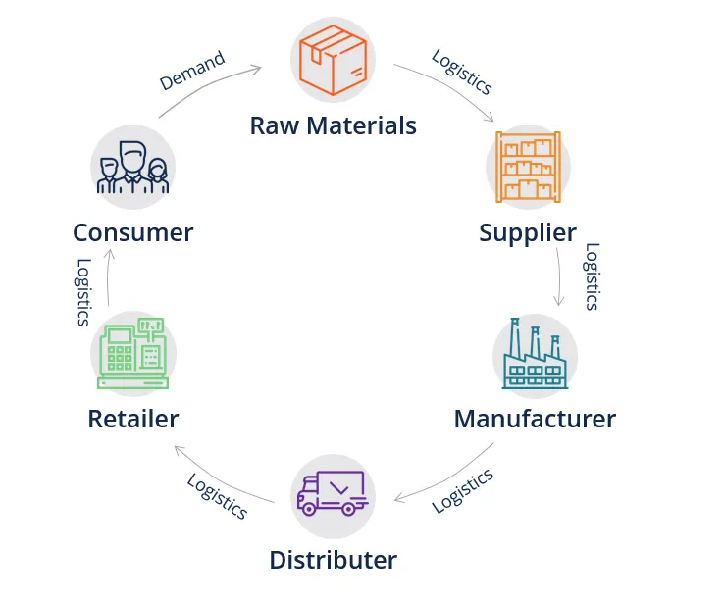
Supply chain flowchart
Description of the product
Hospital intensive care units (ITUs), also termed critical care units (CCUs) or intensive therapy units (ITU), require special hospital equipment that is deployed to provide intensive care services (Vincent et al., 2020). ITUs electronic systems are deployed to cater to patients in life-threatening situations caused by either injuries or illnesses. Vincent et al. (2020) noted that patients under the ITUs unit require close supervision from highly trained nurses, physicians, and therapists to provide exceptional medical care. Currently, nations worldwide have made a tremendous effort to better their intensive care unit for better healthcare services. The facility has to undergo global supply chain processes to establish the hospital intensive care units effectively. This is because the unit will source its parts from the UK, Asian countries, India, and products worldwide. Min (2017) noted that the world is expected to continuously invest in ITUs due to the huge need for better healthcare services.
Electronics from several Asian counties
The system designed, assembled, and tested in the UK
Software element developed in India.

ITUs electronic system

System sold worldwide and maintenance support for at least 10 years

Diagram indicates different types of the supply chain that will be completed in this case. The supply chain will include shipping products from India, UK, China, and Asian Nations to develop hospital care units. These ITUs' electronic system will be again shipped to the global market, accompanied by atleast ten years maintenance.
Risk in Global Supply Chains
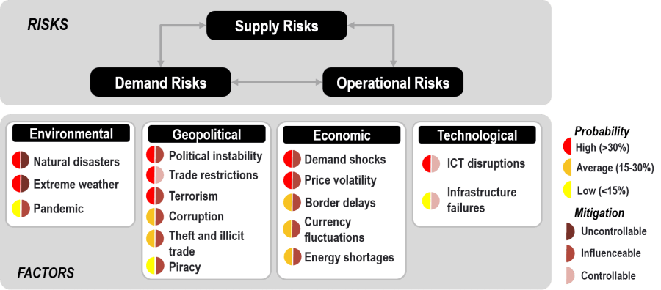
Extracted from: https://transportgeography.org/contents/chapter9/transportation-and-disasters/supply_chain_risks-2/
As indicated in the diagram, supply risks are connected to the demand and operational risks. The supply chain has to meet demand, and functional requirements or whereas give rise to supply disruptions. Further, demand aspects greatly influence the supply chain, where unexpected behavior in demand can result in demand disruption. Finally, the supply chain depends on operational elements to move products from producer to client. Therefore, global supply chain risks rotate around supply, demand, and operational risks. The diagram above indicates different factors that significantly impact supply chain risk.
Environmental and Weather Risk Factors
India, Asia, the UK, China, and other parts of the world have different climates. This makes an environment a significant factor in all organizations completing global supply chains lacking control over. The global supply chain of setting up an intensive care unit can experience extreme weather events. These events include tropical storms, which affect ocean freight routes caused by global warming. In tropical storm instances, shipping products through the ocean have to be recalculated, resulting in delays or more costly as the shippers incur cost to gain flexibility due to those tumultuous periods (El Baz & Ruel, 2021). Other whether calamity includes tsunami waves which affect the ocean navigation. Some part of the globe experience earthquake regularly causing sudden disruption to the global trade routes utilized for the effective global supply chain.
Geopolitical Risk Factors
Geopolitical is the process of relating politics to international relations as influenced by geographical factors—global supply chains experience multiple aspects of related geopolitical risks. El Baz & Ruel (2021) noted that these global supply chain risk factors include conflicts and trade restrictions. Some governments have installed harsh policies for goods sourced out of their boundaries to promote local trade. Further, the global supply chain experiences interstate conflict risks, where two states, nations, or regions are not on good terms, causing a significant challenge to complete the supply chain. Some parts of the world that need hospital intensive care units (ITUs) electronic systems are experiencing political instability. This makes the supply chain face impact when extended to those parts of the globe.
Economic Risk Factors
Min (2017) noted that economic risk factors typically relate to the demand shocks, affecting the power to procure the product. Economic of a nation is dependent on political, economic, and environmental changes (El Baz & Ruel, 2021). For instance, the global supply chain can experience price volatility which dictates input costs. Some government imposes trade restrictions that the organization has to comply with, and some are unfavorable, causing global supply chains. The economic instability of the globe can dramatically cause a reduction in the number of demands for the ITUs system. This will further reduce the need for raw material sourced from UK, India, China, and Asian nations. Therefore, global chain supply is vulnerable to economic stability experienced by one economy involved within the chain.
Technological Risk Factor
Notably, technological advancements are being experienced in every aspect of the globe. This includes a global supply chain process that depends on various technical techniques to be effectively completed. El Baz & Ruel (2021) noted that although technology has positively enhanced international trade, global supply chains are continuously at risk of cyberattacks in their digital part. Cyber-attacks cause issues in data integrity, quality, and even supply consistency. Since supply chains depend on information technology, any attack in the information system can lead to significant trade ramifications.
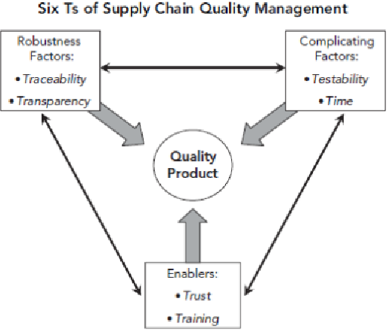
The figure shows six Ts that technology influences in the global supply chain.
Conclusion
ITUs system will be sourced from the UK, part of software India, electronics parts from Asia, and the product sold and maintained globally. Globalization has opened numerous market channels that help individuals and organizations extend their supply chain beyond nations' boundaries. This means the supply chain will have to be conducted through nations. Global supply chain risks are grouped primarily into geopolitical, technological, environmental, and economic risk factors. The global supply chain of setting up an intensive care unit can experience extreme weather events. Therefore, it is essential to aspect these risks for the electronic system's effective supply chain for patient monitoring in hospital intensive care units (ITUs).The supply chain has to meet demand, and functional requirements or whereas give rise to supply disruptions.
References
El Baz, J., & Ruel, S. (2021). Can supply chain risk management practices mitigate the disruption impacts on supply chains' resilience and robustness? Evidence from an empirical survey in a COVID-19 outbreak era. International Journal of Production Economics, 233, 107972.
Min, H. (2017). Health care supply chain research: Where are we going?. Logistics Research, 10(5), 1-19.
Vincent, J. L., Sakr, Y., Singer, M., Martin-Loeches, I., Machado, F. R., Marshall, J. C., ... & Angus, D. C. (2020). Prevalence and outcomes of infection among patients in intensive care units in 2017. Jama, 323(15), 1478-1487.

